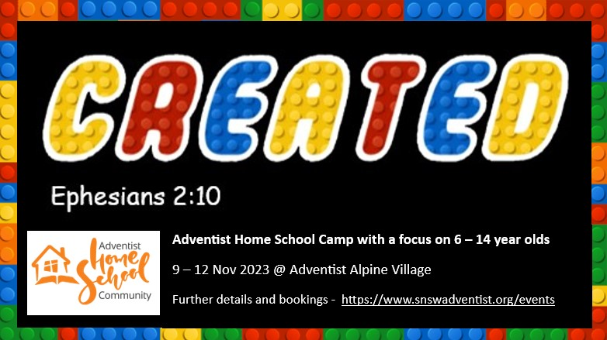

DETAILS

For:
Adventist home school families and their friends with a focus on 6- to 14-year-olds.

Time:
Starts on Thursday the 9th of November at 5 pm with registration.
Finishes on Sunday the 12th of November at 1 pm with lunch.

Accommodation Options – Please note that these prices are heavily subsidised by the Conference.
Chalets and dormitories: $20/person/night
Powered site: $40/night/family
Unpowered site: $25/night/family

Meals - Please note that these prices are heavily subsidised by the Conference.
Adventist Alpine Village is catering for all meals, please plan to support them.
Meals: $7/meal/person
Activity fee
$40 per child includes: T-shirt, craft and activities.

Educational Workshops will be held on Friday morning, each including a variety of age-appropriate activities.

Parent Time will occur on Friday when the children are at their educational workshops. This time will focus on supporting each other as home school parents, sharing resources and relaxing.

Recreation time will include a variety of guided oval games. This will be a time for everyone to play together and build friendships.

12+ hangout will be a supervised time in the evenings for children 12 years old and older. They will participate in guided activities, discussions, games and will be a time for them to build friendships and hangout.

On Sabbath there will be a focus on worshiping our God and fellowship with each other. This will include Sabbath School, Church and an afternoon of social time where we encourage families to spend time with each other in nature.

A Concert will be held on Saturday night. This will be an opportunity for children to perform in front of an audience. Music items, poetry recitals, speeches or short skits can all be included. Parents can assist and items can be Christian or secular. PLEASE PLAN AND PRACTICE for this. Please register your item/s with Erika at the camp and before Sabbath. There will be games in the hall after the concert.

Family Games will be held on Sunday on the oval where families will complete a variety of activities in groups.

The Camp Chaplain will be Pr Lorenzo Berry so if you have any issues or would like special prayer, please feel free to approach him.

If you have any further questions or enquiries, please feel free to contact the camp coordinator Jackie Berry via email: ljasberry@hotmail.com

BOOK ONLINE: https://www.snswadventist.org/events BEFORE: 9 OCTOBER

Program
Thursday  5 – 6 pm - Dinner  7 pm – Worships  8 pm 12+ Hang out.  9 pm – Lights out.  Friday  8 am – Breakfast  9:30 am – Worship  10:00 am – Educational Workshops & Parent Time  12:00 pm – Lunch  1:00 pm – Kids Craft  2:30 pm – Recreation on the oval  4:00 pm – Free time  6:00 pm – Dinner  7:00 pm – Worship  8 pm 12+ Hang out.  9 pm – Lights out | Sabbath  8 am – Breakfast  9:30 am – Sabbath School  11:00 am – Church  12:00 pm – Lunch  1:00 pm – Free family fun time  6:00 pm – Dinner  7:00 pm – Worship  7:30 pm – Concert and Games.  10 pm – Lights out.  Sunday  8 am – Breakfast  9:30 am – Worship  10:00 pm – Family games  12:00 pm – Lunch  1:00 pm - Home

